Lexington County Sheriff’s Office Detention Bureau
PREA ANNUAL REPORT - 2022

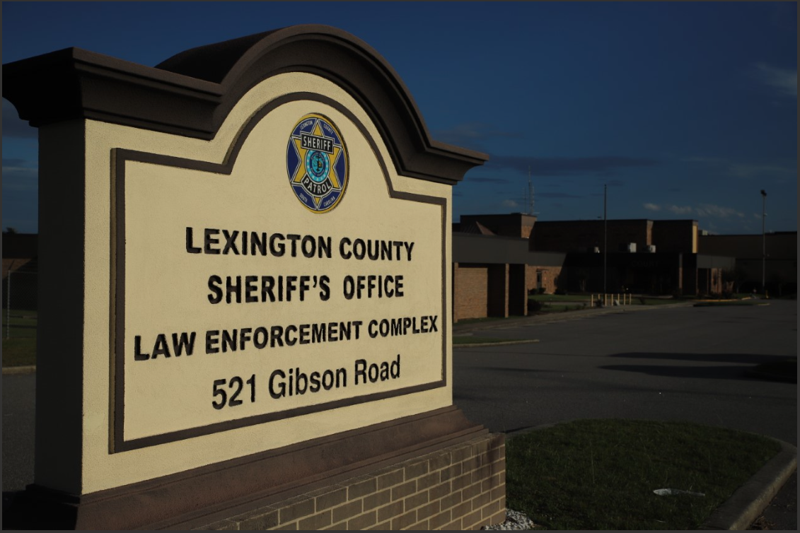
Agency Mission and Vision

MISSION: To work as a professional law enforcement team to build relationships with those we are sworn to serve
VISION: Making Lexington County a safer place

Lexington County Sheriff’s Office
Detention Bureau

Prison Rape Elimination Act (PREA) Coordinator’s
Annual PREA Report

Date: March 23, 2023

To: Sheriff Brian Jay Koon

Through: Major Robert Singleton
Legal Joel Deason

From: PREA Coordinator Walter E Todd

Subject: PREA Compliance Annual Report for Year 2022

Reference: (a) 28 CFR 115 Prison Rape Elimination Act- National Standards
- Section 44-23-1150; S.C. Code of Laws (Sexual misconduct with an inmate, patient or offender)
- Lexington County Sheriff’s Office Detention Bureau Policy’s 105, 301.7, 3.55 and 404.6

Enclosure: Prison Rape Elimination Act (PREA) Findings and Corrective Actions

PREA Standards §115.88 and §115.89 require the Lexington County Sheriff’s Office to maintain, review and collect data related to allegations of sexual abuse at its Detention Center. This is a report of our agency’s findings and corrective actions.
The standards also require the enclosed report to be posted on our agency’s website for public access.

TABLE OF CONTENTS

REPORT SUMMARY 5

2022 AGGREGATION OF DATA
2022 Aggregated Allegations of Sexual Abuse/Sexual Harassment with Female Victim v. Male Victim
Comparison 6
Historical Comparison 2020-2022 7

Allegation Breakdown 7

Corrective Actions 8

Schedule of Audits English 9

Schedule of Audits Spanish 10

LEXINGTON COUNTY SHERIFF’S OFFICE
DETENTION BUREAU
ANNUAL PREA REPORT

Background and Introduction
President George W. Bush signed the Prison Rape Elimination Act (PREA) into federal law in September 2003. The purpose of the law is to provide information, resources, recommendations and funding to protect individuals from sexual harassment and sexual abuse in confinement facilities. The Lexington County Sheriff’s Office Detention Bureau maintains a “zero tolerance’ policy against sexual abuse and sexual harassment and provides guidelines for the prevention, detection, response, investigation and tracking of allegations of sexual abuse and sexual harassment of offenders within the facility.
All sexual abuse and sexual harassment allegations are investigated. Each case is documented on an incident report and entered into the Lexington County Sheriff’s Office Detention Bureau’s PREA event log. Twenty-eight investigators have received specialized training. The agency is required to complete an administrative investigation and is required to retain all investigation documents. Our CSI investigators depending on the nature of the alleged incident can also criminally investigate allegations. Upon completion of each investigation, appropriate disciplinary action is taken against the perpetrator; when criminal intent is discovered, the case is presented to the Solicitor for prosecution.
The Lexington County Sheriff’s Office Detention Bureau strives to improve reporting and investigation methods to ensure the highest level of compliance and implements corrective action as necessary. The agency’s zero tolerance policy aims to protect all detainees in the Lexington County Sheriff’s Office Detention Bureau from sexual harassment and sexual abuse in addition to protecting those who report allegations from retaliation.

Purpose
This report summarizes all PREA allegations made in 2022. Data from the facility is collected and aggregated on the following categories: 1) Inmate-on-inmate Sexual Abuse; 2) Inmate-on-Inmate Sexual Harassment; 3) Staff-on-Inmate Sexual Abuse (Misconduct); and 4) Staff-on-Inmate Sexual Harassment.
Upon completion of an investigation, all allegations will be categorized into one of the following dispositions: 1) Substantiated (the allegation was determined to have occurred); 2) Unsubstantiated (there was insufficient evidence to make a final determination as to whether the event did or did not occur); 3) Unfounded (the allegation was proven to not have occurred); or 4) Non PREA (Complaints that are put in the system as a PREA complaint but are not PREA related).

REPORT SUMMARY

The PREA Coordinator’s office is pleased to provide this annual report of PREA activities and implementation efforts for 2022.
In 2022, The Lexington County Sheriff’s Office Detention Bureau received 38 reported allegations of sexual abuse/sexual harassment. Twenty-eight of those complaints were found to be Non PREA leaving 10 appropriate allegations. Of those 10, six were unfounded and four were unsubstantiated.
Training on the National PREA Standards, “Prevention, Detection and Response to Sexual Abuse/Sexual Harassment”, was conducted with all contract employees, volunteers and detention staff during orientation training or through National Institute of Correction classes provided in 2022, in addition to the annual mandatory PREA training provided by the agency’s training division.
Lexington County’s contractual medical provider offers Mental Health services including emotional support services to incarcerated survivors of sexual abuse. The Lexington County Detention Bureau continues our partnership with Pathways to Healing to provide emotional support services and counseling to non-incarcerated survivors of sexual abuse.

Previous PREA Audits:
In 2017 and 2020, an auditor certified by the United States Department of Justice audited the Lexington County Sheriff’s Office Detention Bureau for compliance with the National PREA Standards. Both audits resulted in a 100% compliance with the National PREA Standards.

In 2017 the department received “Exceeds 3 standards, met 40 standards, and 0 not met”
In 2020 the department received “Exceeds 3 standards, met 42 standards, and 0 not met”

According to the 2022 aggregated data of reported allegations of sexual abuse/sexual harassment, two victims were female and eight were male, which equates to 20% and 80% respectively.

AGGREGATED ALLEGATIONS OF SEXUAL ABUSE/SEXUAL HARASSMENT
WITH FEMALE VICTIM v. MALE VICTIM COMPARISONS

Of the 10 reported cases of sexual abuse/sexual harassment in 2022, zero cases were substantiated. The majority of incidents were inmate-on-inmate sexual abuse allegations (3); staff-on-inmate sexual harassment (3); followed by inmate-on-inmate sexual harassment (2) and lastly staff-on-inmate sexual misconduct (2).
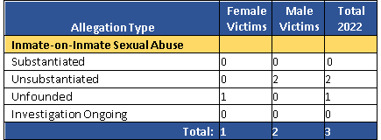
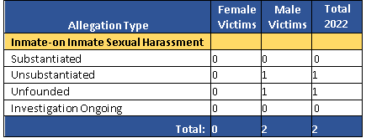
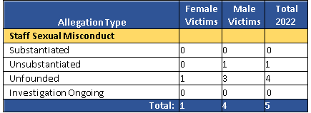
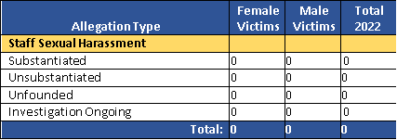
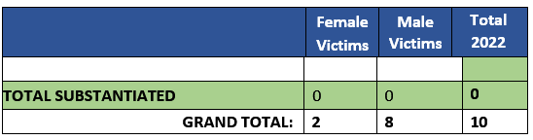

COMPARISON DATA 2020 – 2022

Allegation Type | 2020 | 2021 | 2022 | TOTALS
INMATE ON INMATE SEXUAL ABUSE
Substantiated | 1 | 0 | 0 | 1
Unsubstantiated | 2 | 2 | 2 | 6
Unfounded | 1 | 11 | 1 | 13
Investigation ongoing | 0 | 0 | 0 | 0
TOTAL | 4 | 13 | 3 | 20
INMATE ON INMATE SEXUAL
HARASSMENT
Substantiated | 0 | 0 | 0 | 0
Unsubstantiated | 0 | 1 | 1 | 2
Unfounded | 1 | 8 | 1 | 10
Investigation ongoing | 0 | 0 | 0 | 0
TOTAL | 1 | 9 | 2 | 12
STAFF/CONTRACT SERVICES EMPLOYEES SEXUAL MISCONDUCT
Substantiated | 0 | 0 | 0 | 0
Unsubstantiated | 0 | 0 | 1 | 1
Unfounded | 0 | 4 | 1 | 5
Investigation ongoing | 0 | 0 | 0 | 0
TOTAL | 0 | 4 | 2 | 6
STAFF/ CONTRACT SERVICES EMPLOYEES SEXUAL HARASSMENT
Substantiated | 1 | 0 | 0 | 1
Unsubstantiated | 0 | 1 | 0 | 1
Unfounded | 8 | 4 | 3 | 15
Investigation ongoing | 0 | 0 | 0 | 0
TOTAL | 9 | 5 | 3 | 17
Totals: | 14 | 31 | 10 | 55
TOTAL SUBSTANTIATED/ UNSUBSTANTIATED INCIDENTS OF SEXUAL VIOLENCE | 03 | 02 | 02 | 07

Comparing the data presented in the spreadsheet above, allegations increased by 121% from 2020 to 2021; however, from 2021 to 2022 we experienced a 68% decrease in allegations. An increase in allegations of inmate-on-inmate sexual abuse since 2019 indicates the communications plan is working, as it appears detainees feel they are safe to report allegations. Allegations of Inmate-on-Inmate Sexual Harassment, Staff Sexual Misconduct and Staff Sexual Harassment decreased over the last year. Additionally, the number of total substantiated cases remains low.

CORRECTIVE ACTIONS

To ensure the Lexington County Sheriff’s Office continues its path to full compliance with Federal PREA Standards, the PREA Coordinator and PREA Compliance Managers have implemented several corrective actions to address issues in 2022.
- Video Monitoring: In 2022, the Lexington County Sheriff’s Office Detention Bureau was able to upgrade its security camera system to increase coverage and improve video monitoring for the protection of detainees and staff.
- Medical and Mental Health Screenings: The Lexington County Sheriff’s Office Detention Bureau continues to improve this process by including an alert for inmates who disclose prior sexual abuse. These cases are submitted to the Mental Health group to initiate a meeting with those inmates where emotional support services are offered.
- Documentation: The Lexington County Sheriff’s Office Detention Bureau continues to modify and update our documentation processes to improve data collection and streamline our investigative processes. We hold numerous trainings to ensure staff are aware of these procedures.
- Physical Plant: Due to their age, the Lexington County Sheriff’s Office Detention Bureau buildings are in need of significant repairs and upgrades. The Bureau Commander and PREA Coordinator are working with Facilities Maintenance to address concerns noted by the PREA auditor.
- Screening for Risk of Sexual Victimization and Abusiveness: The Lexington County Sheriff’s Office Detention Bureau continues to improve its timely PREA Risk Screening initial and 30-day reassessment processes.
- Inmate Education: The Lexington County Sheriff’s Office Detention Bureau has modified its inmate training procedures. Medical staff provides PREA paperwork to inform detainees of the reporting process and detention staff reads PREA information to detainees, which detainees read and acknowledge on the kiosks. We also plan to install a TV monitor in the Booking lobby to continuously display a presentation on how to report sexual assaults and harassment in the near future.
- Training: The Lexington County Sheriff’s Office Detention Bureau conducts PREA training with staff, contract workers, volunteers and new hires annually. We also conduct refresher training as needed throughout the year.

SCHEDULED AUDIT NOTICE
ENGLISH AND SPANISH

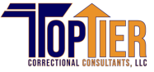
NOTICE
SCHEDULED PREA AUDIT

The Lexington County Detention Center will be undergoing an audit for compliance with the United States Department of Justice’s National Standards to Prevent, Detect and Respond to Prison Rape under the Prison Rape Elimination Act (PREA) 12-15 JUNE 2023.

Since this is a training audit, the information received will be shared with members of the training cadre, but will otherwise be managed confidentially, in accordance with the PREA Standards.

Any person with information relevant to this compliance audit may confidentially* correspond with the auditor via the following address:

Top Tier Correctional Consulting, LLC
P.O. Box 569
Lenoir City, TN 37771

*CONFIDENTIALITY – All correspondence and disclosures during interviews with the designated auditor are confidential and will not be disclosed unless required by law. These are exceptions when confidentiality must be legally broken. Exceptions include, but are not limited to the following:

- If the person is an immediate danger to her/himself or others (e.g. suicide or homicide);
- Allegations of suspected of child abuse, neglect or maltreatment;
- In legal proceedings where information has been subpoenaed by a court of appropriate jurisdiction.

AVISO
AUDITORIA DE PERA
